Day 11 - Geerthana
Project 1: Employee and Department Analysis
SELECT e.name, d.dept_name FROM employees e INNER JOIN departments d ON e.dept_id = d.dept_id;
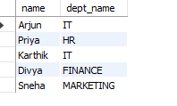
SELECT d.dept_name, e.name FROM departments d LEFT JOIN employees e ON d.dept_id = e.dept_id;
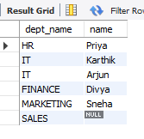
SELECT d.dept_name, AVG(e.salary) AS avg_salary FROM employees e JOIN departments d ON e.dept_id = d.dept_id GROUP BY d.dept_name;
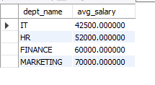
Project 2: Customer Segmentation using Subqueries
SELECT * FROM orders;
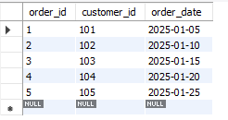

SELECT * FROM ratings;
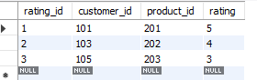
SELECT customer_id FROM orders WHERE customer_id NOT IN (SELECT customer_id FROM ratings);
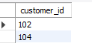
SELECT o.customer_id FROM orders o LEFT JOIN ratings r ON o.customer_id = r.customer_id WHERE r.customer_id IS NULL;
Project 3: Product-Sales Analysis
• Objective: Find the total sales revenue for each product category.
• Technique: JOIN a products table with a sales table and use GROUP BY to sum the total sales for each category.
SELECT * FROM products;
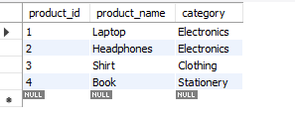
SELECT * FROM sales;
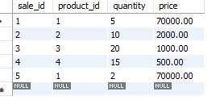
SELECT p.category, SUM(s.quantity * s.price) AS total_revenue FROM sales s JOIN products p ON s.product_id = p.product_id GROUP BY p.category;
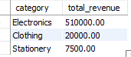

Project 2: Employee Performance with Subqueries
Find all employees whose performance score is above the company-wide average.
SELECT * FROM employee_performance;
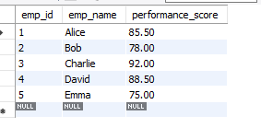
SELECT emp_name, performance_score FROM employee_performance WHERE performance_score > (
SELECT AVG(performance_score)
FROM employee_performance
);
